**MA374 – LAB02**

**Name: Sahil Kumar Gupta**

**Roll Number: 200123081**

**Q1**

Given Data:

S(0) = Initial Stock Price = 100

K = Strike Price = 100

T = Time to maturity = 1 year

r = Risk Free Rate = 8%

σ = Volatility of the stock = 20%

At each time step, the stock's price can rise by a factor of u or fall by a factor of d.

The formula for u and d –

**Set1: ${u= e}^{σ\sqrt{Δt}} , {d= e}^{-σ\sqrt{Δt}}$**

**Set2: ${u= e}^{σ\sqrt{Δt}+\left(r- \frac{σ^{2}}{2}\right)Δt} , {d= e}^{-σ\sqrt{Δt}+\left(r- \frac{σ^{2}}{2}\right)Δt}$**

The probability (q) of an upward return in price is ${R-d}/{u-d}$, where R = $e^{rΔt}$ and 𝛥𝑡 = 𝑇/𝑀 with M being the number of subintervals in the time interval [0,T].

At expiry, i.e, t = T, we calculate the price of the option using the respective payoff function for both the call and put option, i.e,

***CnM = max(SnM – K, 0) and PnM = max(-SnM + K, 0)***

where 0 <= n <= M and CnM is the nth possible price of the call option for the Mth interval, and PnM is the nth possible price of the put option for the Mth interval

n

n

Now, we continuously apply **Backward Induction** to find out the option price at t = 0 by using following relation:

***Cni = (1-p) Cn+1i+1 + (p) Cni+1 and Pni = (1-p) Pn+1i+1 + (p) Pni+1, 0 <= n <= i & 0 <= i <= M - 1***

C00 and P00 are the required values, i.e, initial option prices.

In the below graphs, we have done the sensitivity analysis first by changing only a single factor and then by changing 2 at a time.

Note: It took around 5 minutes for the code to run on my computer.

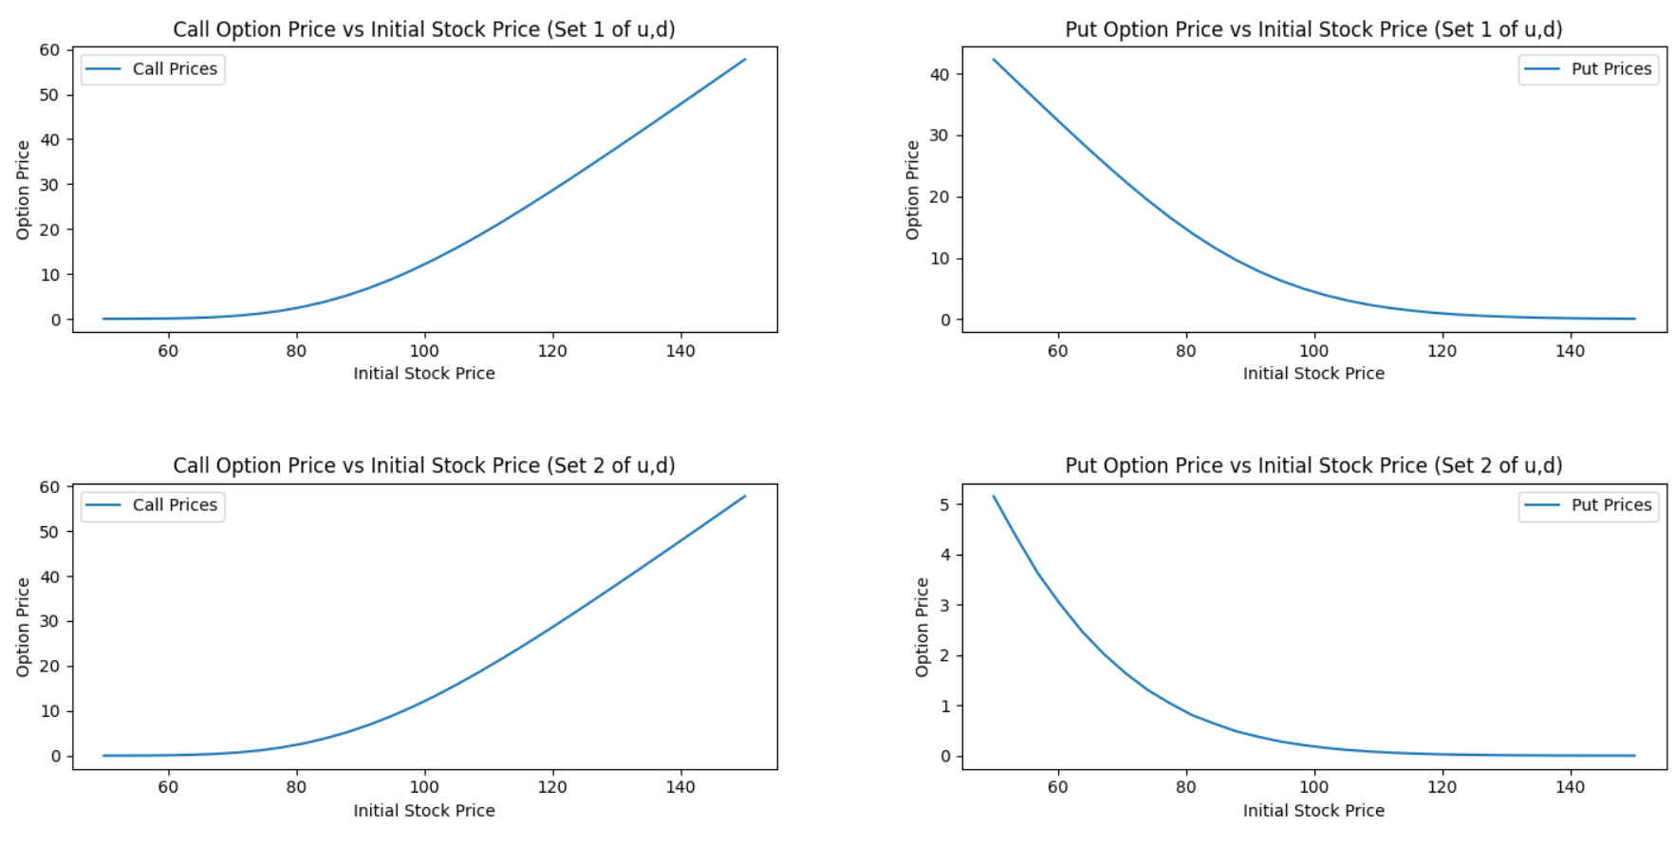 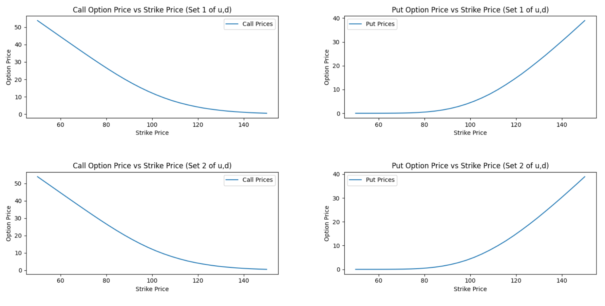 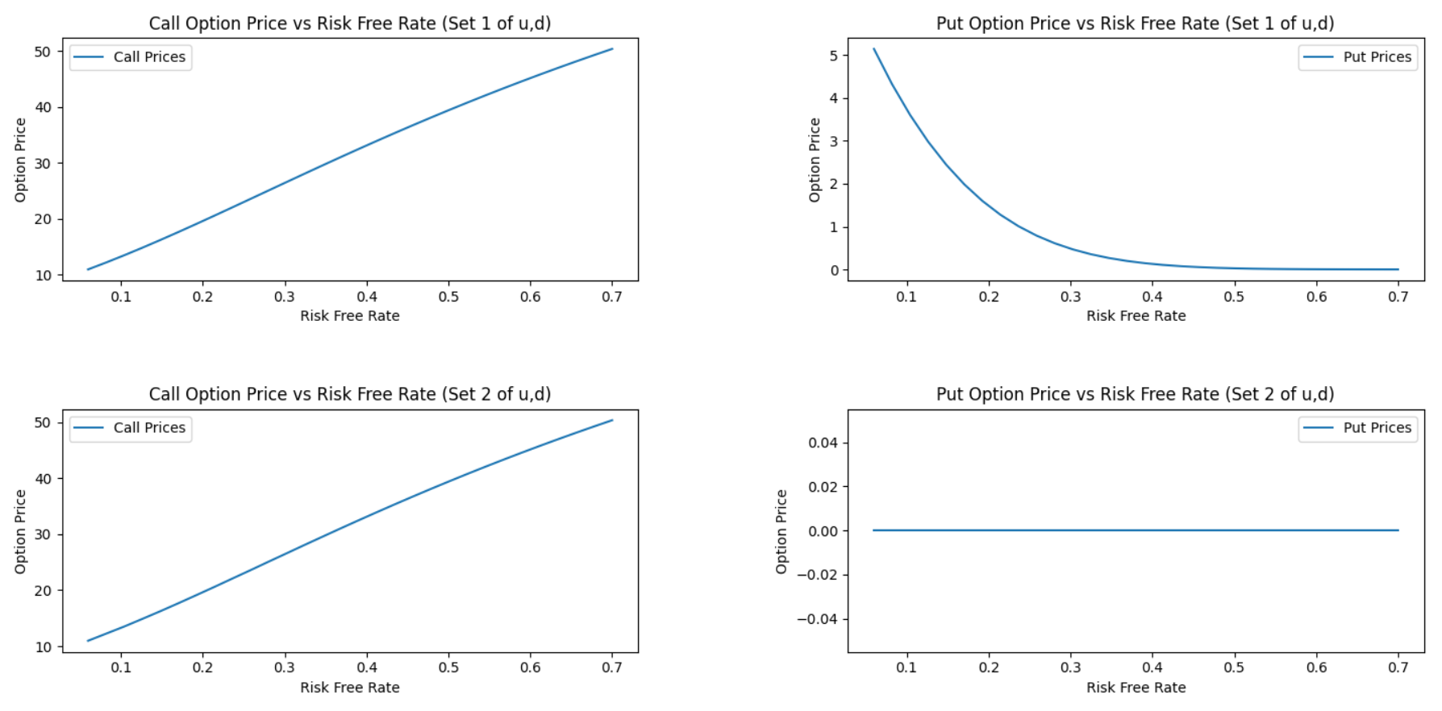 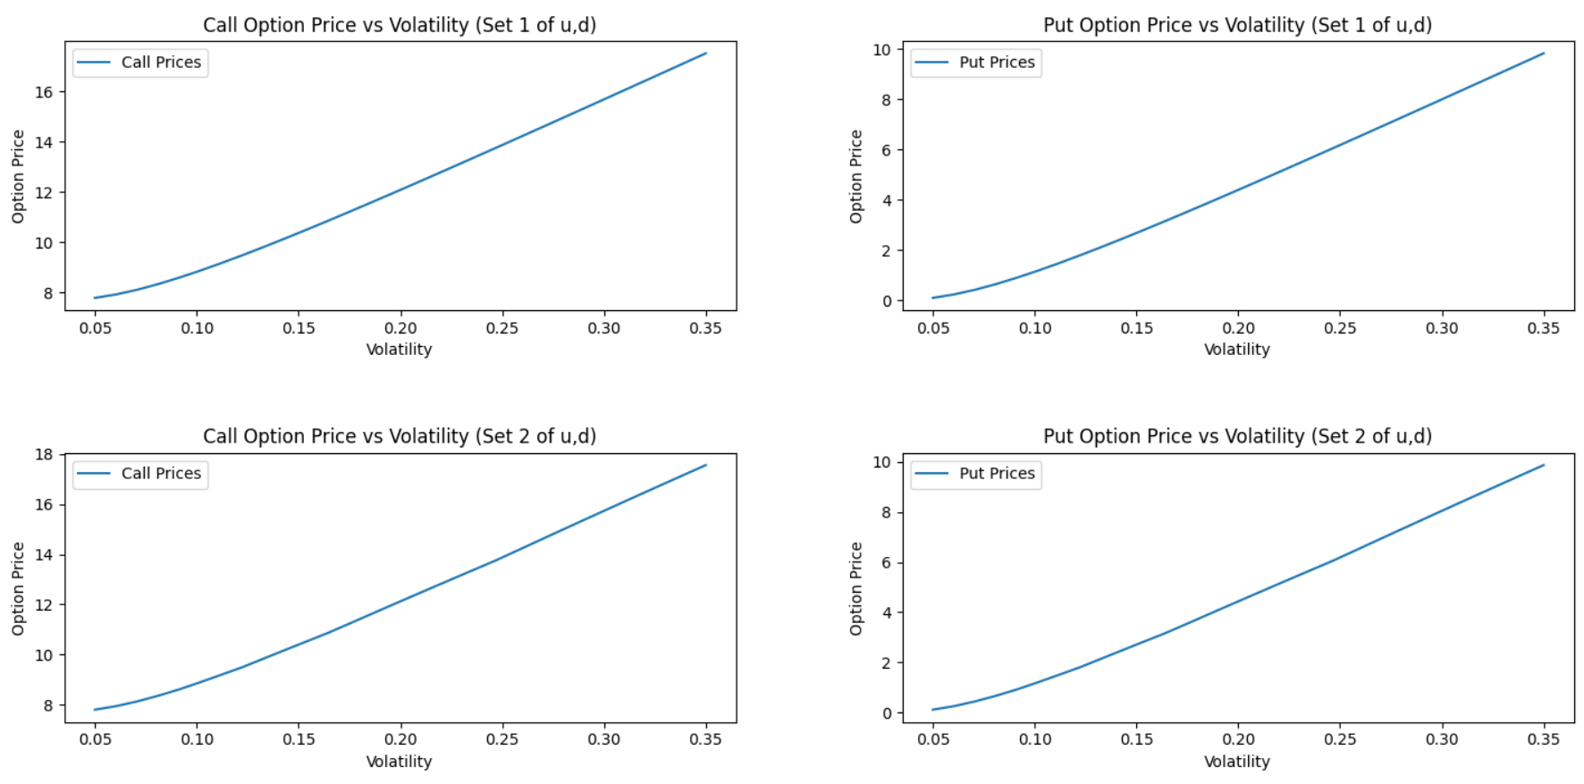 **a) K = 95**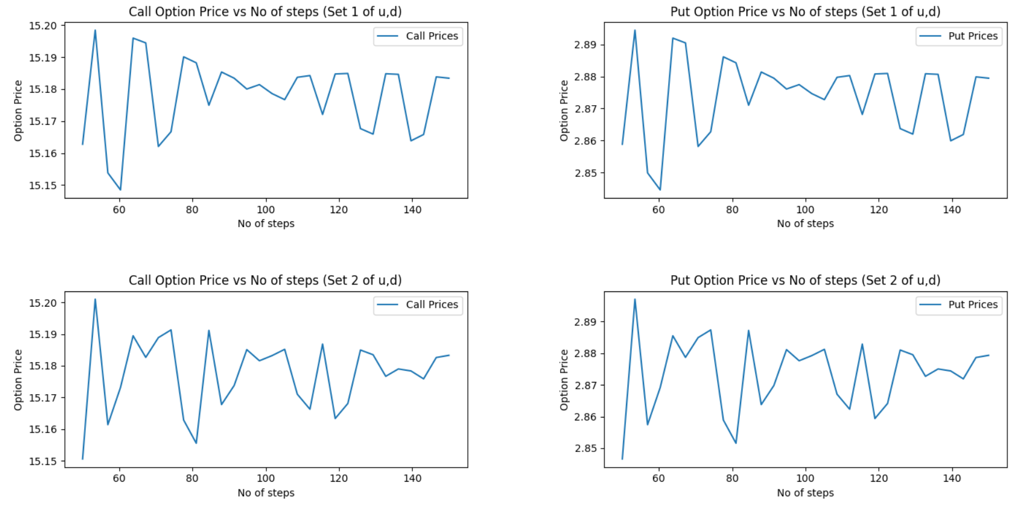

**b) K = 100**

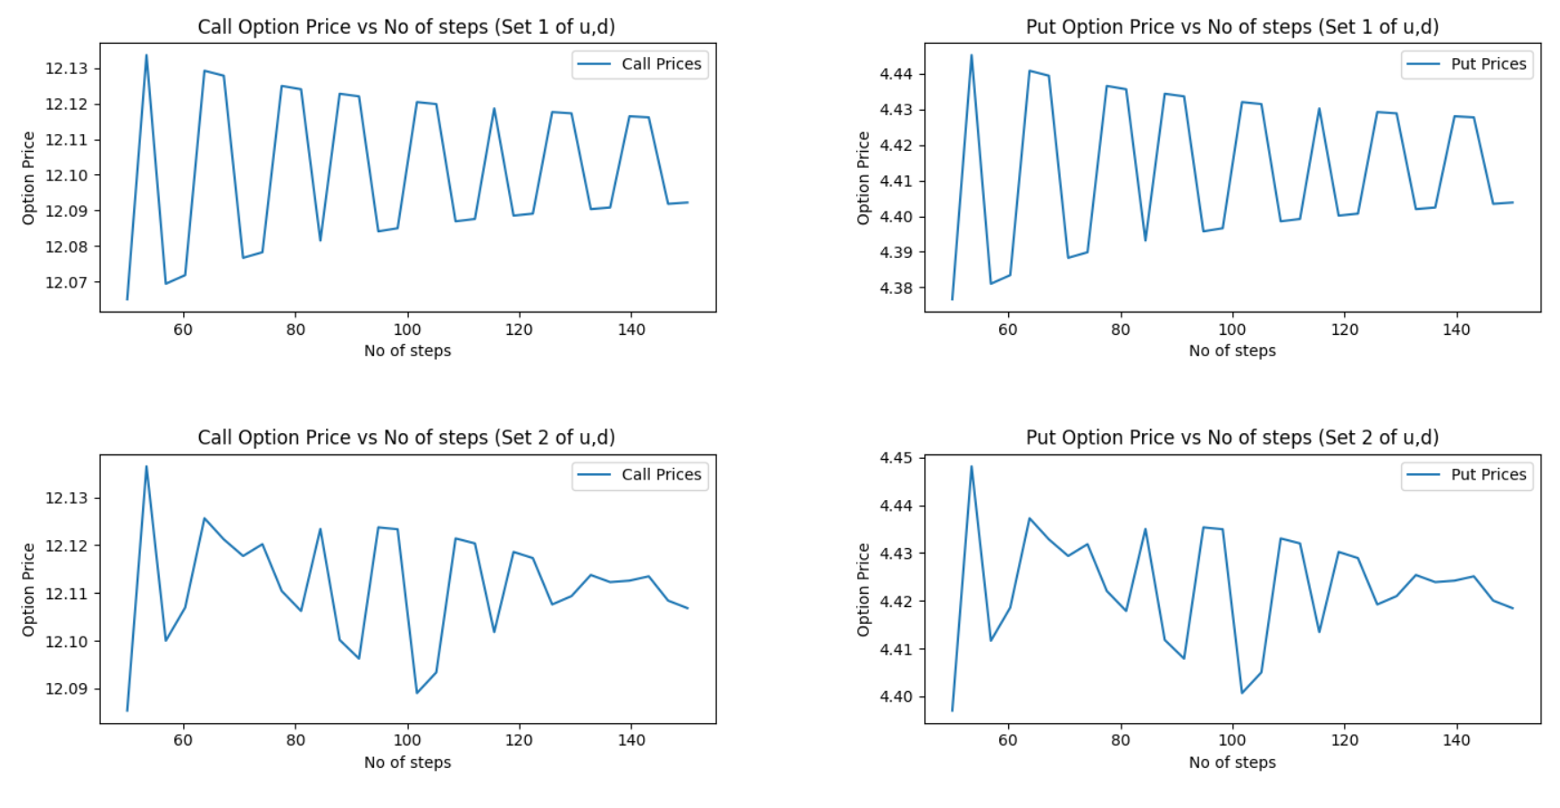

**c) K = 105**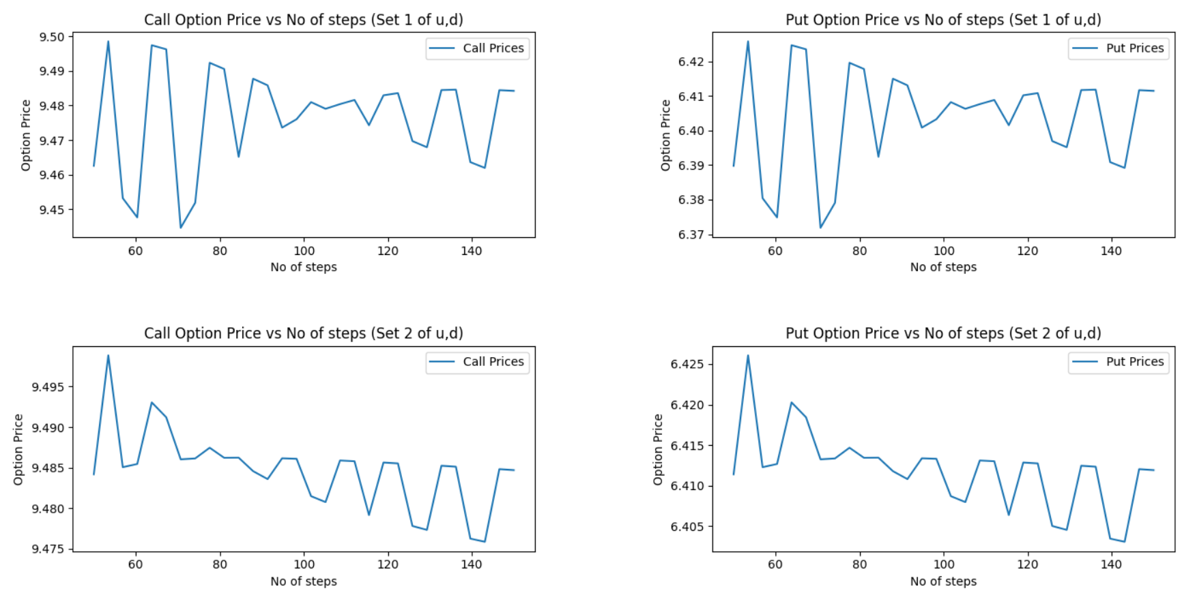

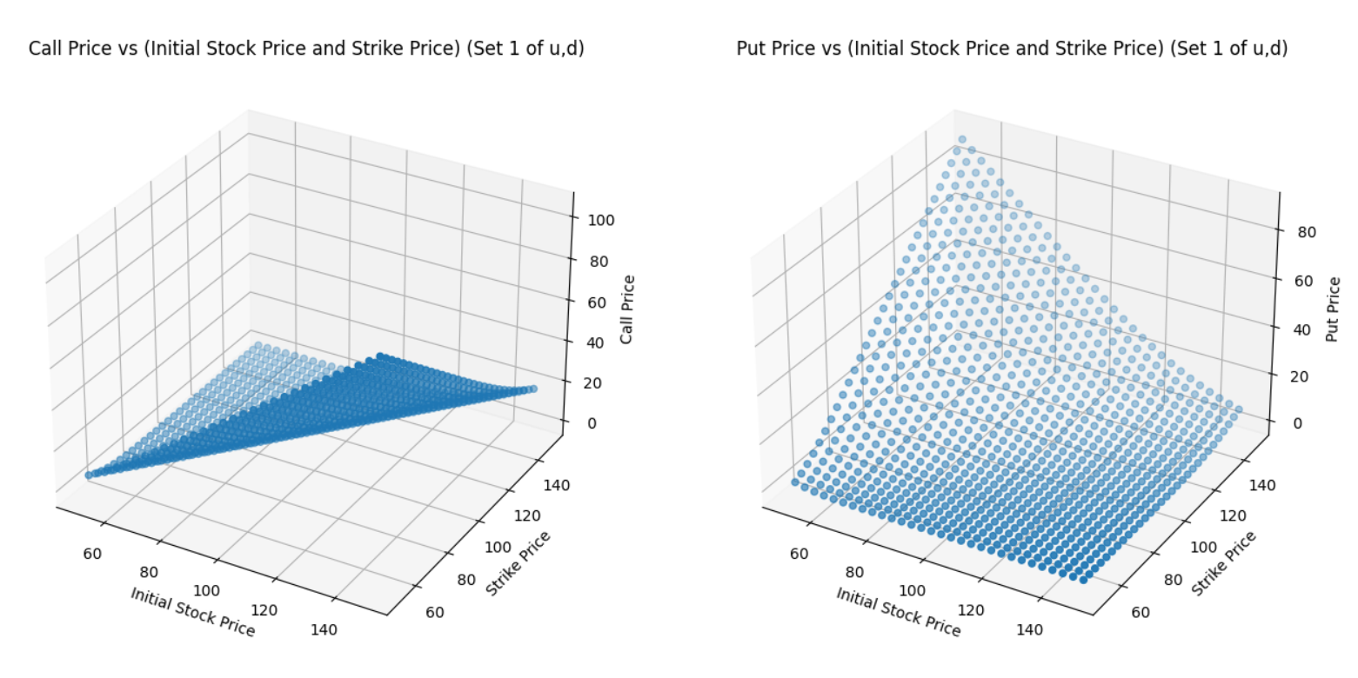 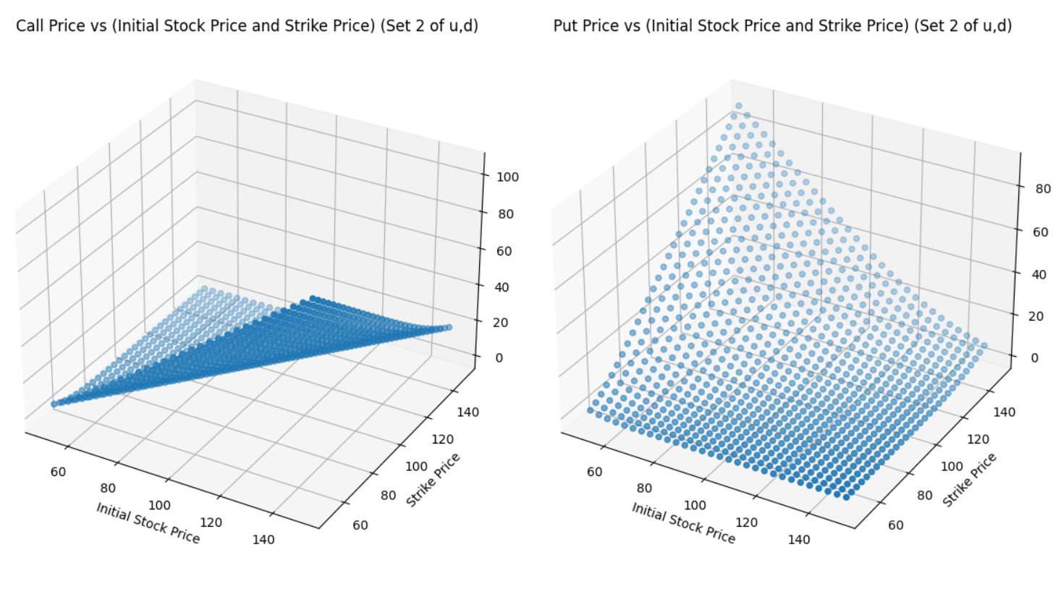

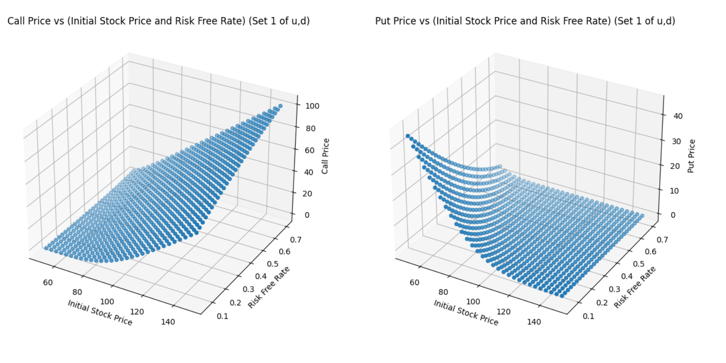 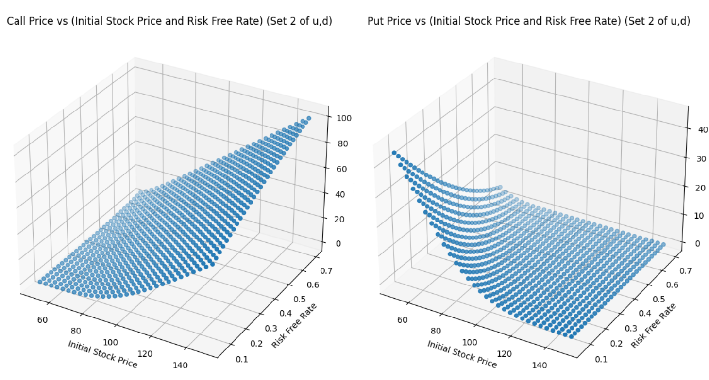

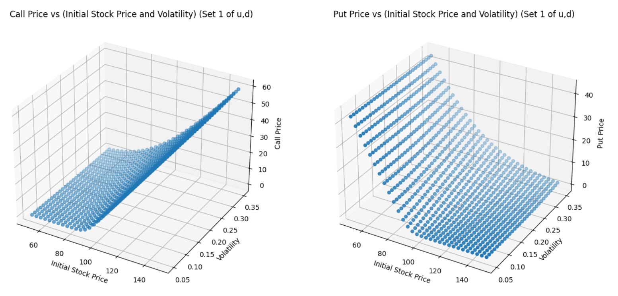 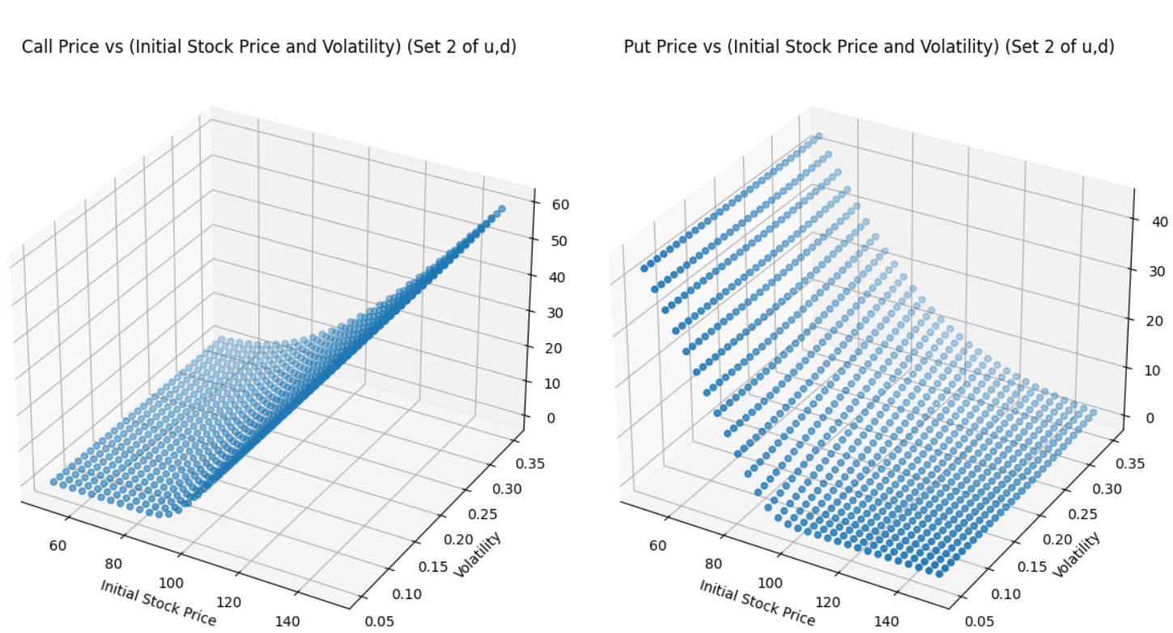

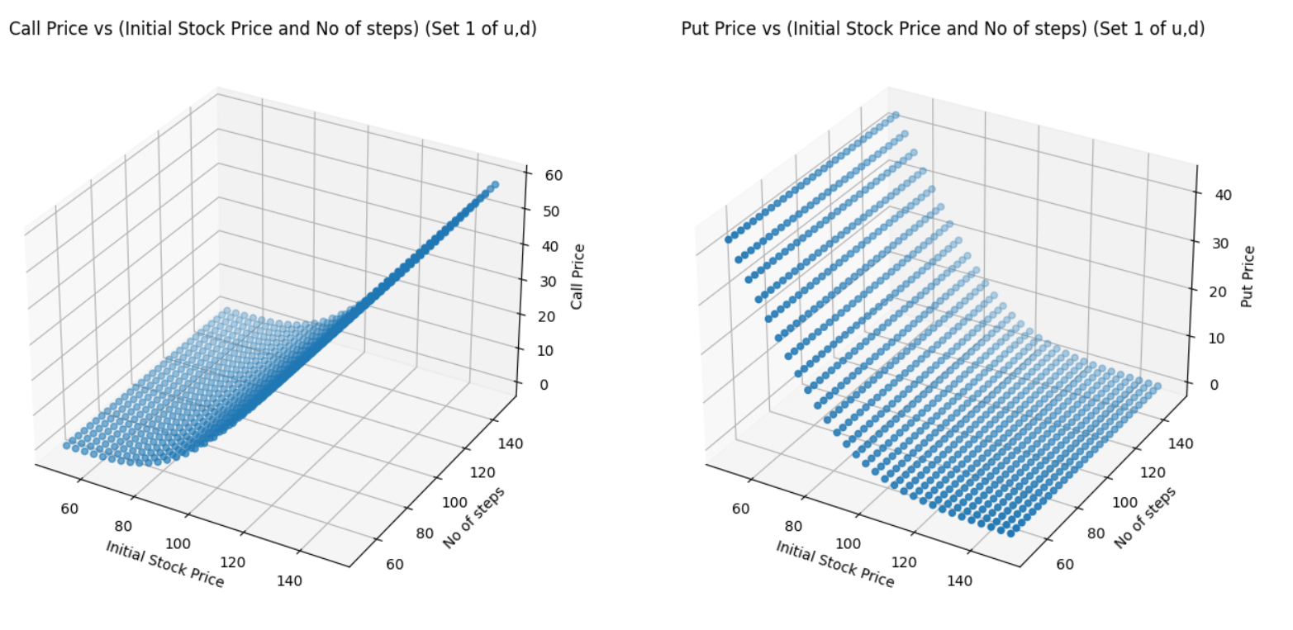 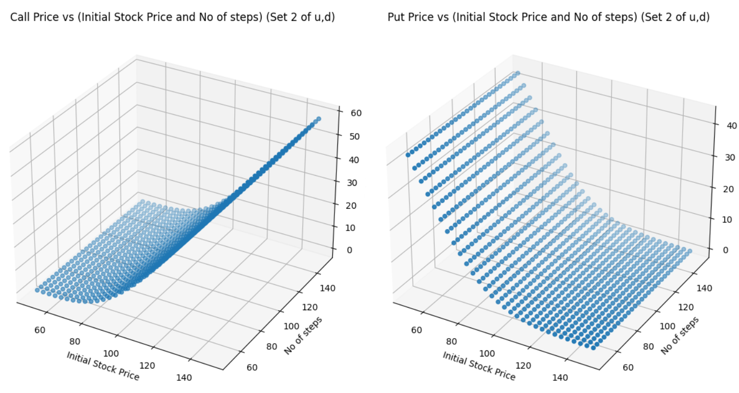

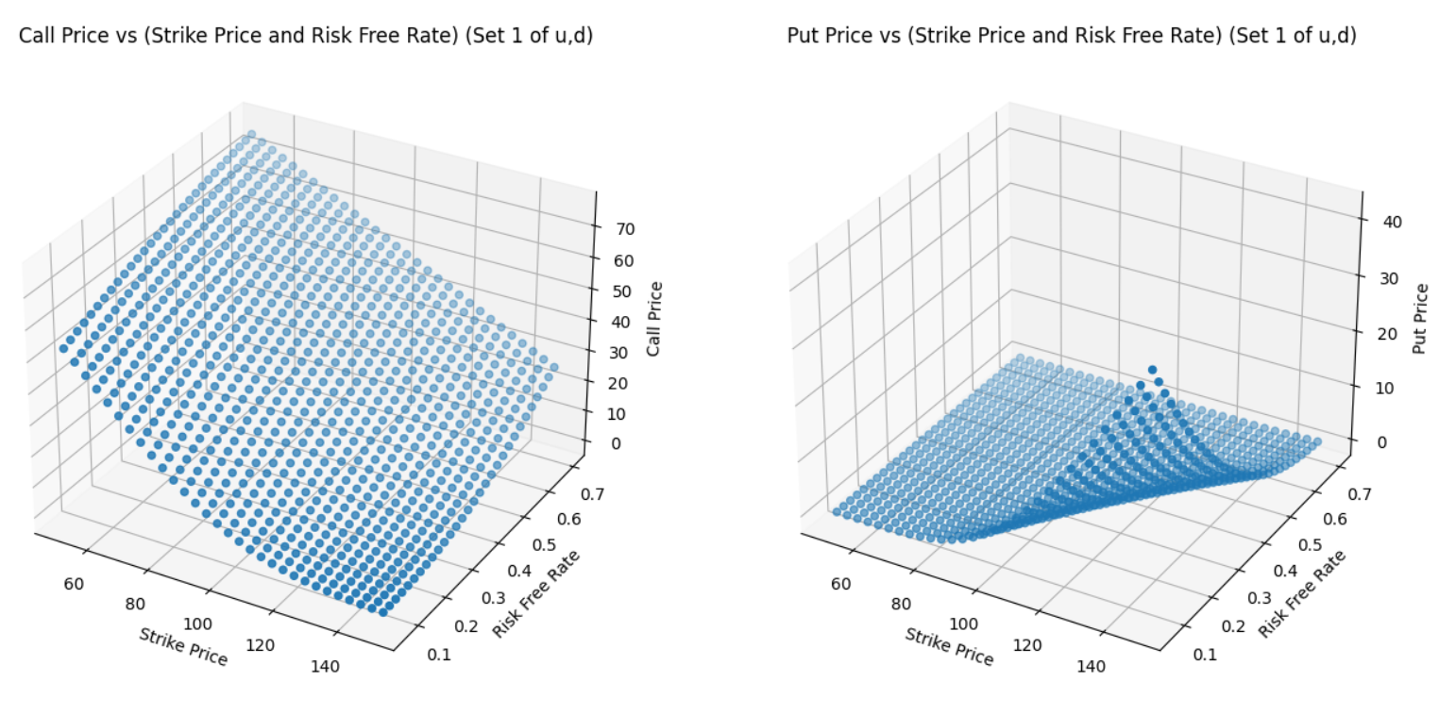 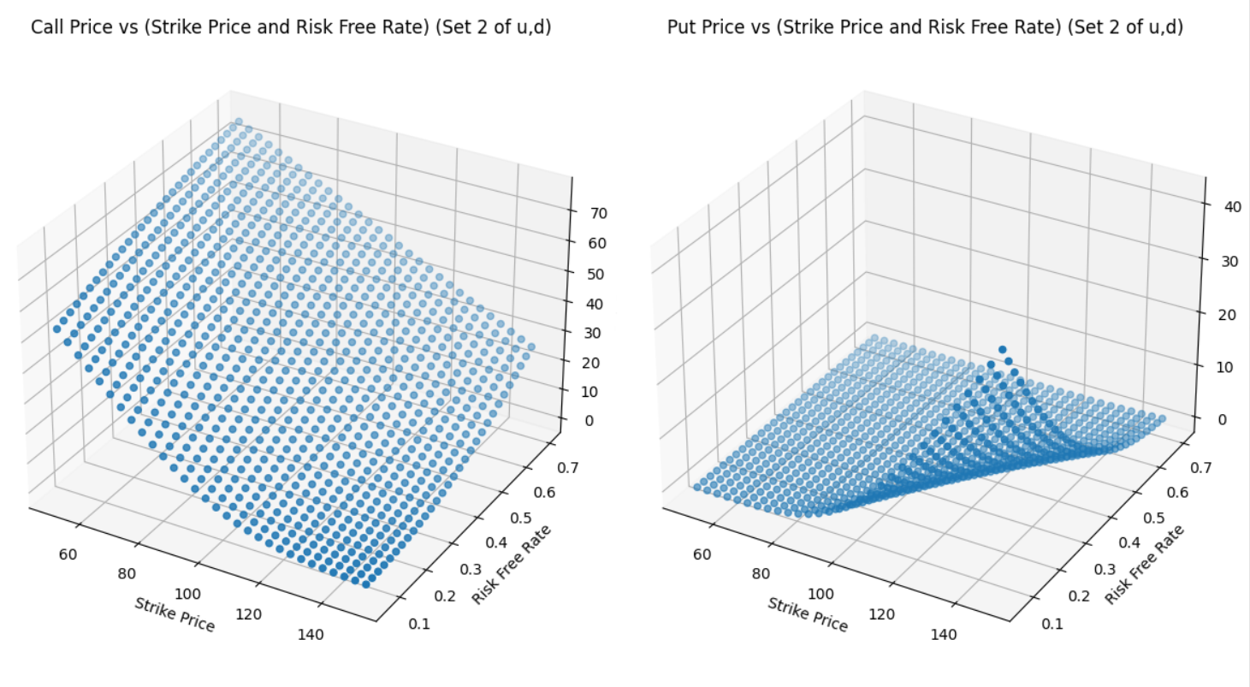

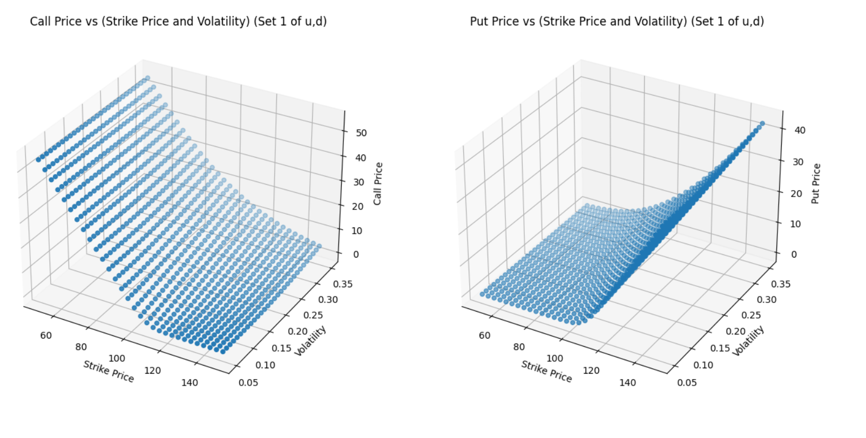 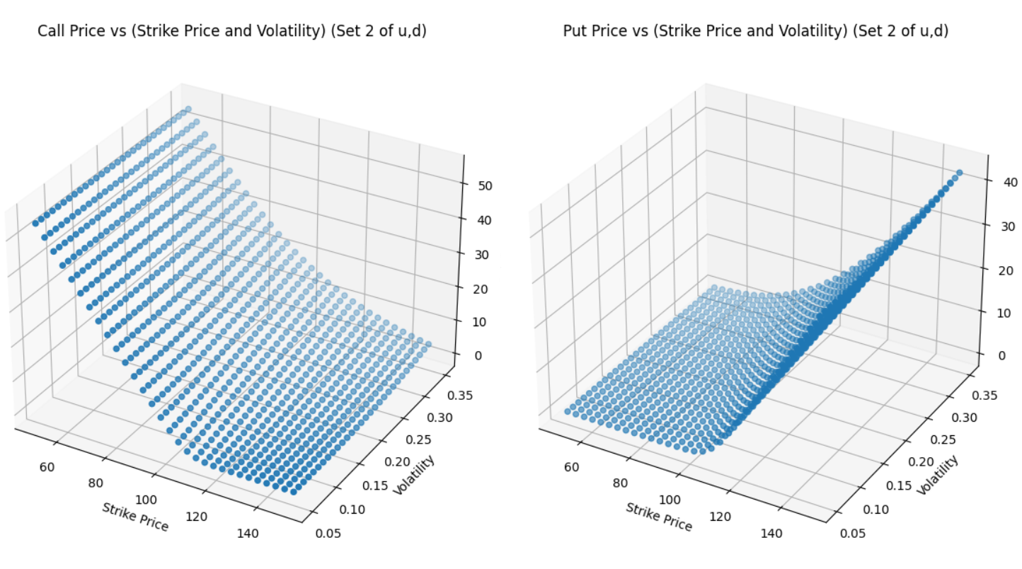

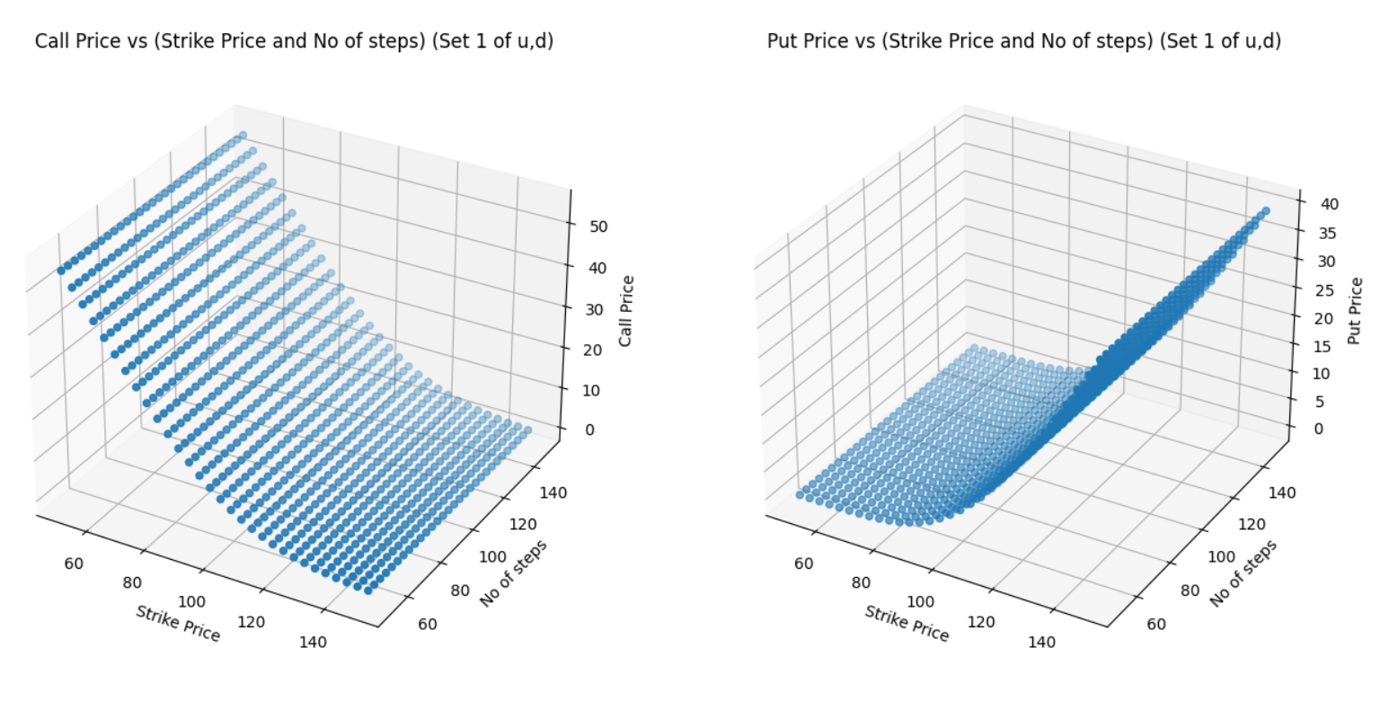 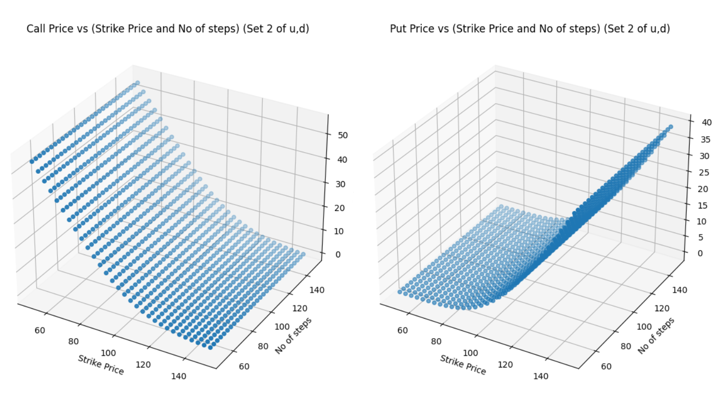

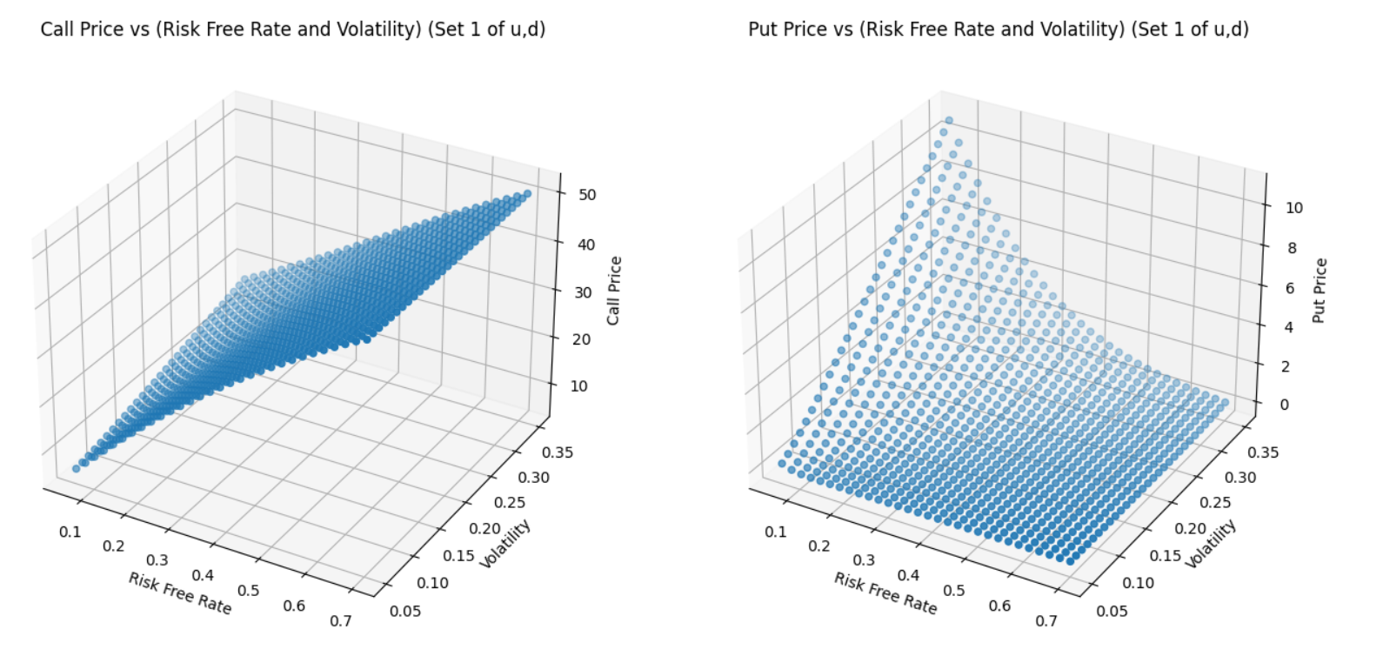 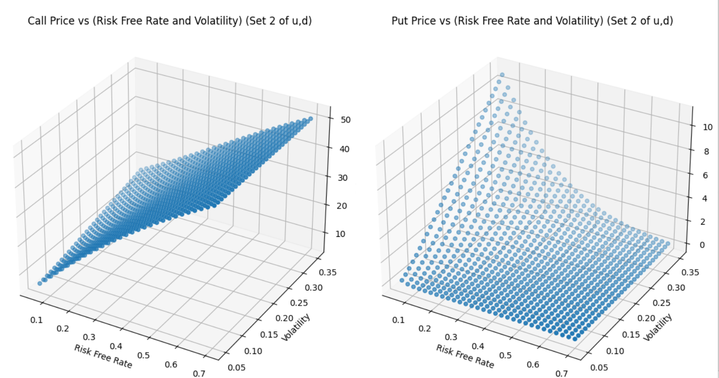

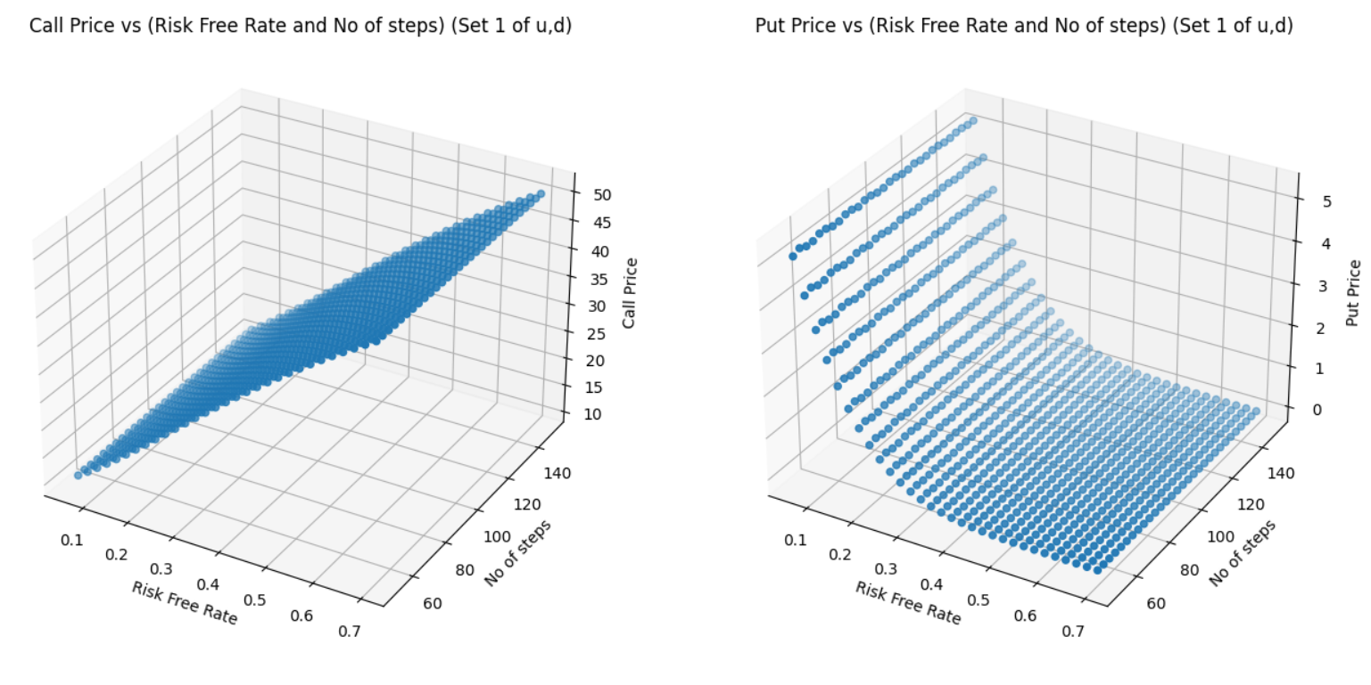 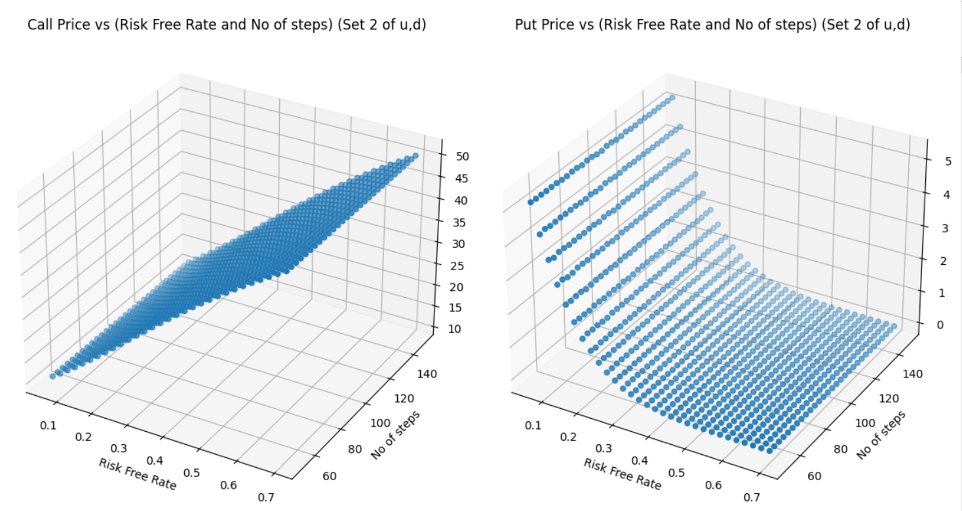

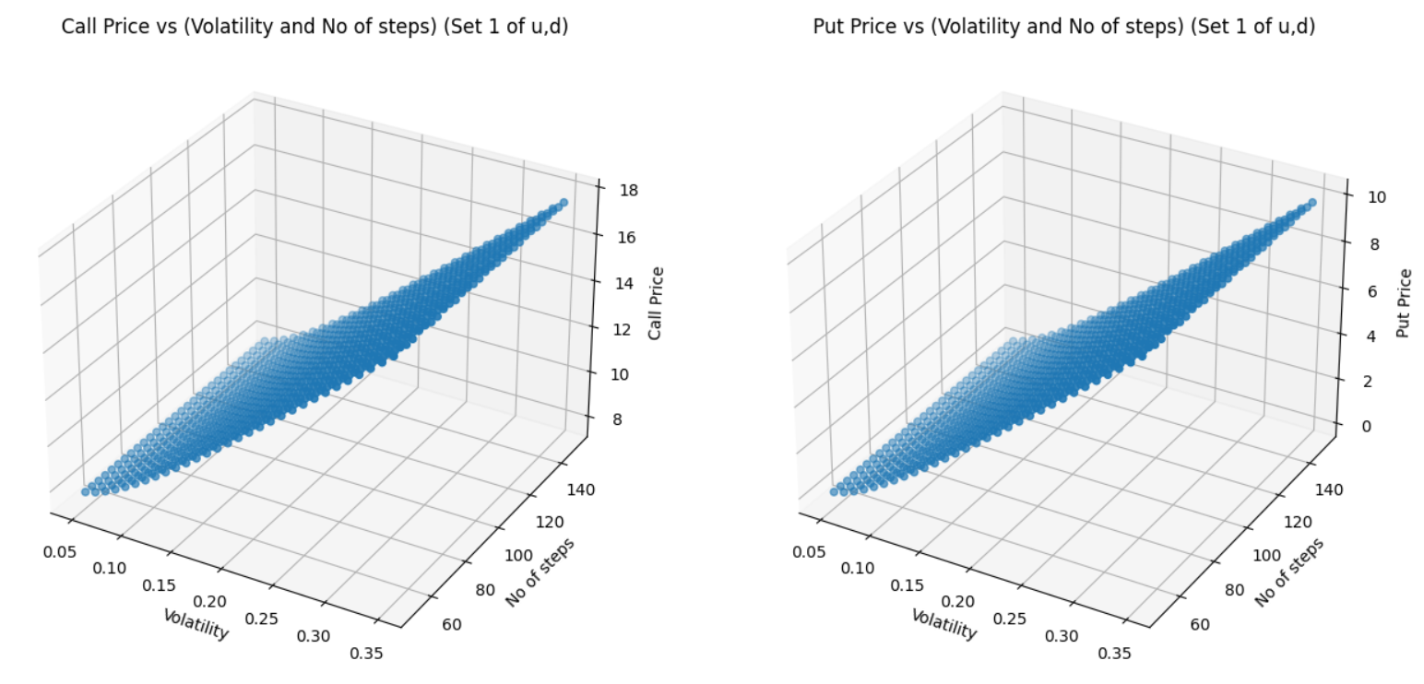 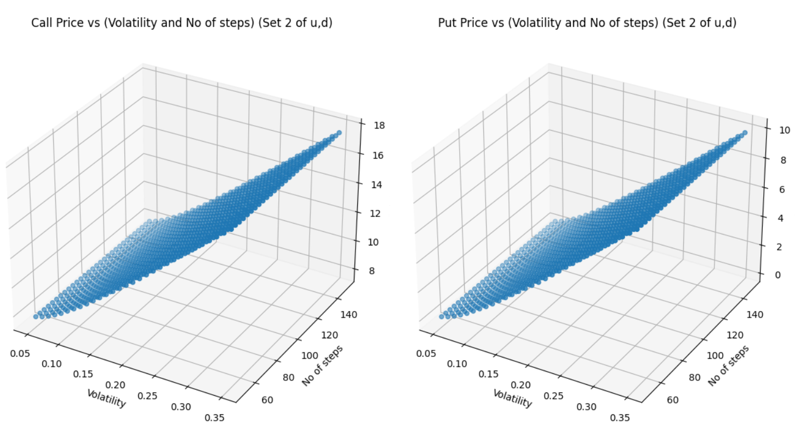

**Q2**

This question is done by choosing the path dependent derivative to be Asian Options.

For this question we have taken M as 10 because Algorithm for calculating price is O(2^M).

The **payoff for Asian Option** at expiry T can be given as:

$$\frac{1}{e^{rT}}\sum{q^{number of ups}{(1-q)}^{M- number of ups}} f(Savg)$$

where f(Savg) is the final payoff calculated using following formula –

for call option – max(Savg(T) - K, 0)

for put option – max(K – Savg(T),0)

Savg is the average stock price along any particular path.

In the below graphs, we have done the sensitivity analysis first by changing only a single factor and then by changing 2 at a time.

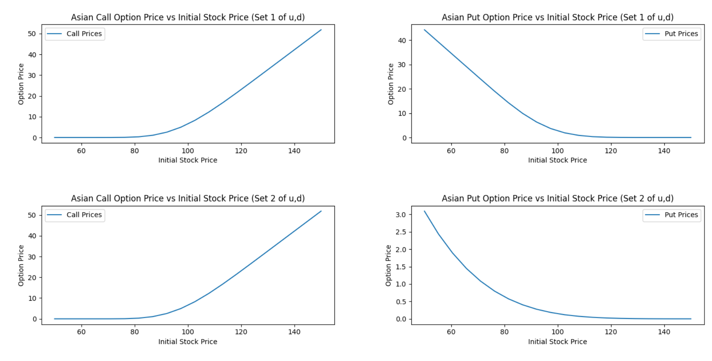

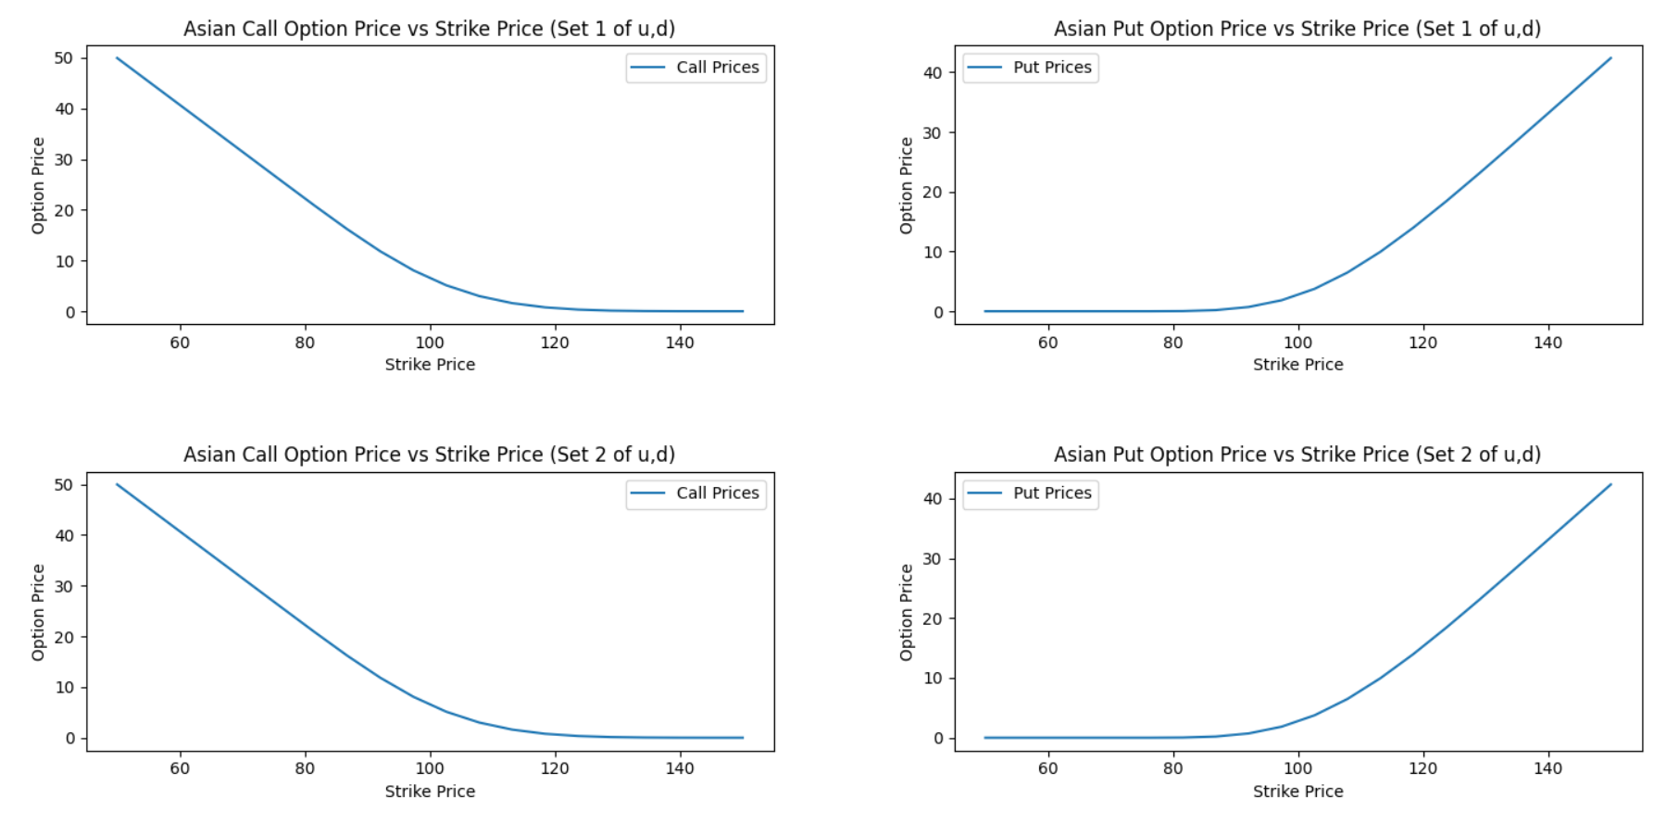

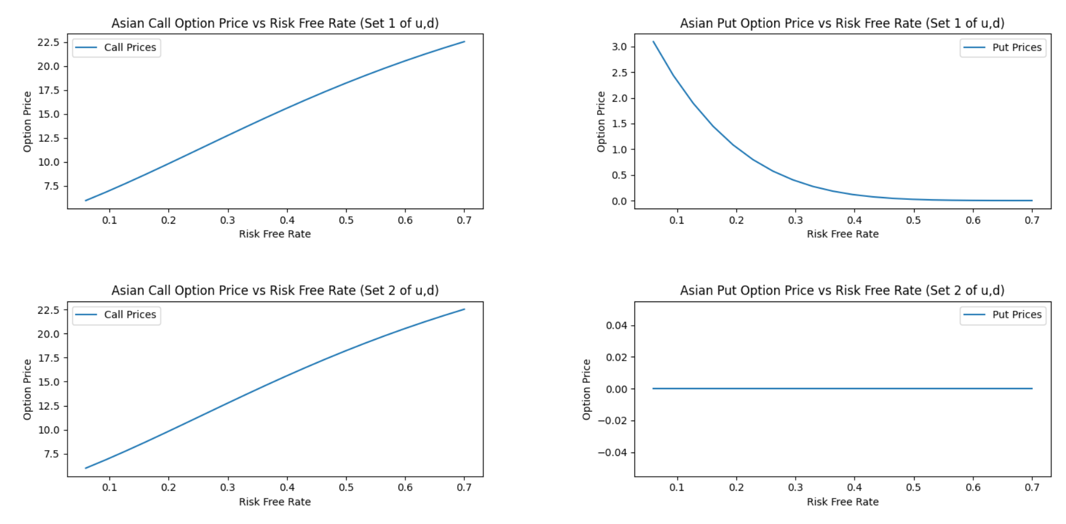

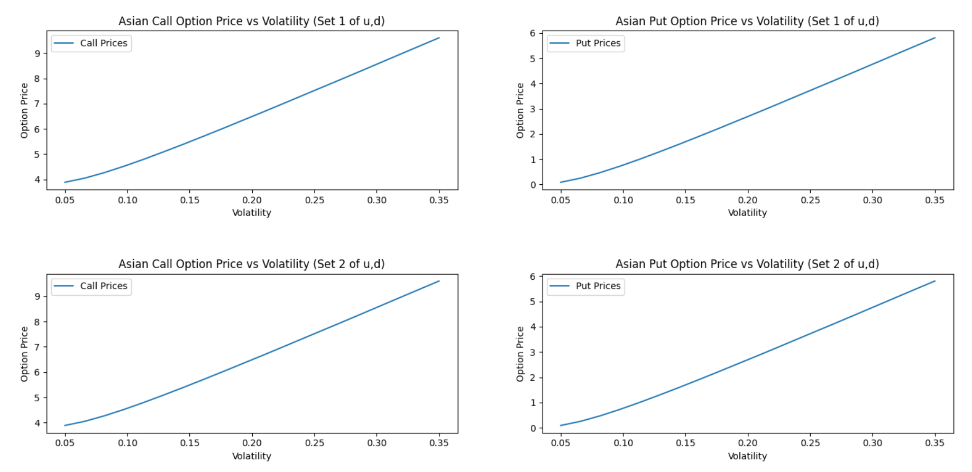

1. **K = 95**

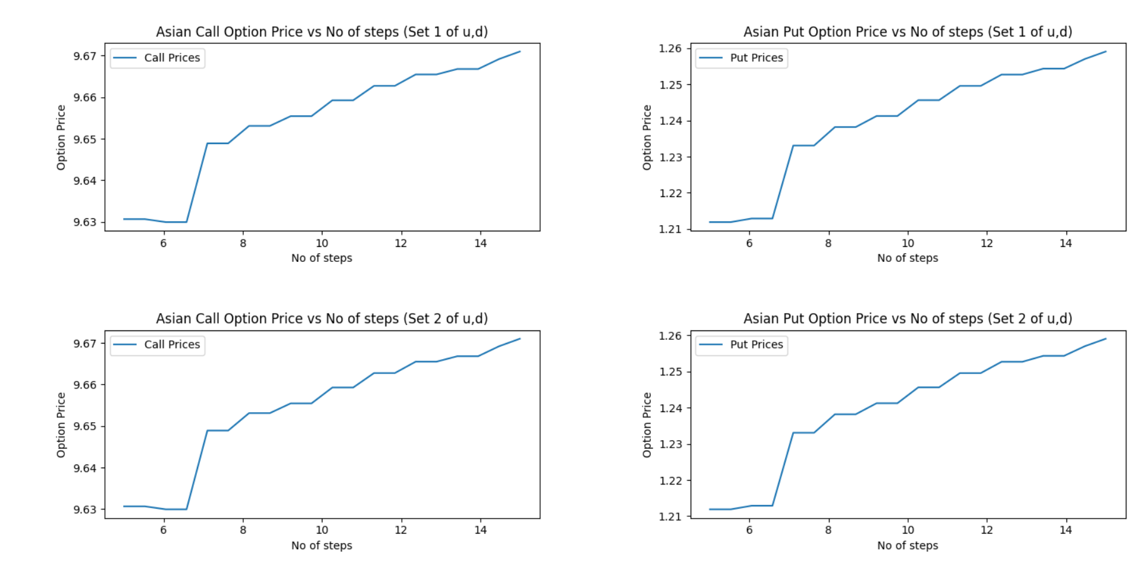

1. **K = 100**

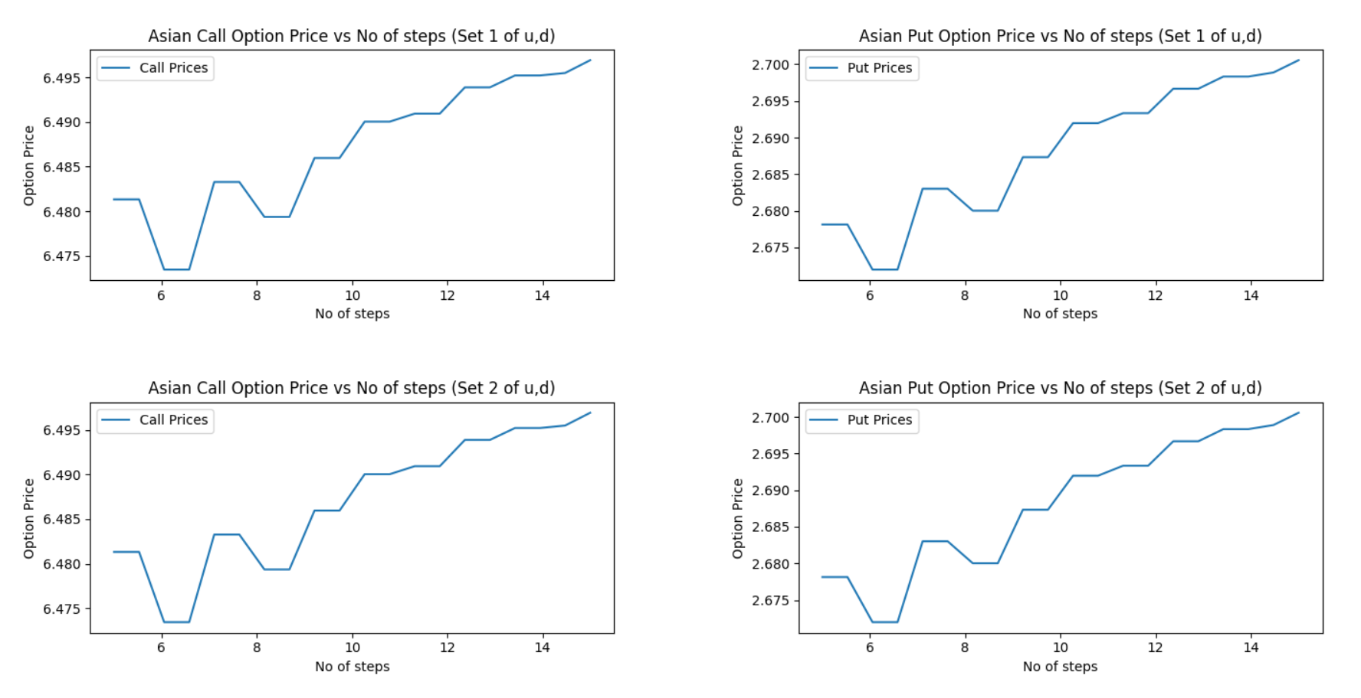

1. **K = 105**

 